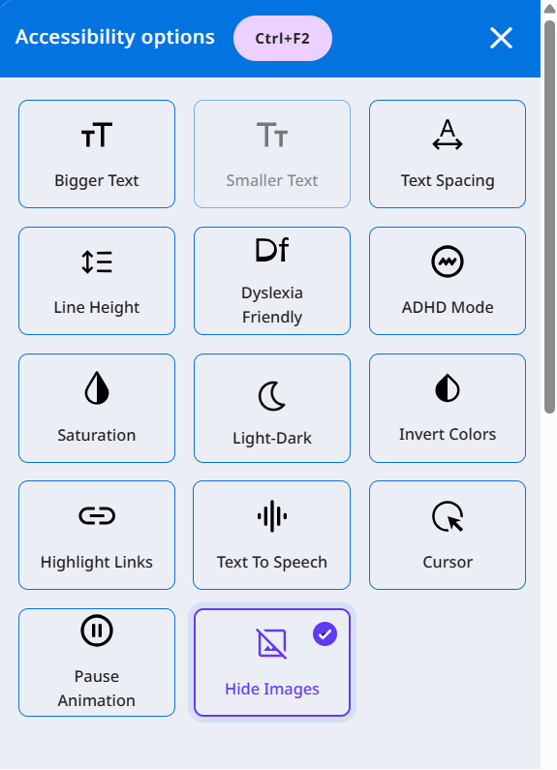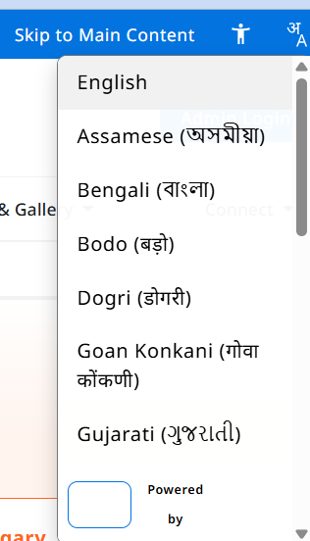

Buttons use
(for next ok lig in and all other buttons )Particle Button : Button that bursts animated particles from its center on click with a quick scale press effect, built with React, Motion, and Tailwind CSS.
(for submit button and task completion button )Magnet Button : Magnetic button that pulls floating particles to its center on hover using Motion spring animations, built with React and Tailwind CSS.

we can use Card Flip
Interactive card that flips in 3D on hover to reveal features and a call to action, built with React and Tailwind CSS transforms and transitions. in home page description places and something liek Apple Activity Card
Animated activity rings card inspired by the Apple Fitness app, with progress circles built in React using Tailwind CSS and Motion animations. in final report page and scorces and Carousel Cards
Horizontally scrolling card carousel with ratings, badges and arrow navigation, built with React, Tailwind CSS and shadcn/ui primitives.for pictures to zoom and Mouse Effect Card
Interactive card with an animated dot pattern that repels away from the cursor, powered by React, Tailwind CSS and Motion spring physics. in login ior if this take more complex and hit our network lacentcy we dont need it and this Profile Dropdown
User profile dropdown menu with avatar, subscription and model details, and quick action links, built with React, shadcn/ui, and Tailwind CSS. fro profile top right side and Smooth Tab and use Feature bento
An example of a staggered feature bento with scroll-triggered reveals and considered hover micro-interactions in Motion for React.

Preview
Source
npx shadcn@latest add @motion/bento-staggered

for show the final report sho like this :
Animated tab switcher with a sliding active indicator and smooth card content transitions, built with React, Motion, and Tailwind CSS. fro checking models usage things uded and one in prole and we can use Morphic Navbar
Navigation bar whose active link morphs into a rounded pill with smooth CSS transitions, built with React, Next.js Link, and Tailwind CSS. for the hoe m page and Loader
Animated loading indicator with rotating gradient rings, size variants and customizable title text. Built with React, Tailwind CSS and Motion. for our all global oading things and File Upload
Drag and drop file upload with animated progress, file validation and error states. Built with React, Tailwind CSS and Motion animations. fro file upaodinf if we need add this att last and AI Voice
AI voice input button with recording timer, pulsing waveform bars and listening state. Built with React and animated Tailwind CSS styles.

fro our voice assistant thet run on screen but below at bottom on front aslo could be abel e to scroll according to the gyuid in say in teh web to see offerent things fro notifications in the app like successfyul use Toast stack
Animated with hardware accelerated transforms and opacity, styled with your existing design tokens

Preview
Source
npx shadcn@latest add @motion/overlay-toast-stack next is testimnilas Testimonials card stack
An example of a draggable testimonial card stack that re-fans as you flick the top card away in Motion for React. and add this keleton loader
An example of skeleton shimmer placeholders that morph into loaded content in Motion for React.

Preview
Source
npx shadcn@latest add @motion/loader-skeleton

also what ever i said here is the example and template this should be used the project with the description i am making

Preview
Source
npx shadcn@latest add @motion/testimonials-stack

add this with the navigation ui i said earlier --> Navigation: Mega menu
An example of a site navigation with a single shared mega-menu panel that morphs directionally between sections, in Motion for React.

Preview
Source
npx shadcn@latest add @motion/nav-mega-menu and fro footer we can use Footer: Sticky reveal
An example of a sticky under-page footer that fades and scales in as scroll uncovers it, in Motion for React.

Preview
Source
npx shadcn@latest add @motion/footer-sticky-reveal aslo we can use this fro faq at last or in the home page what we do and below descriotion --> FAQ: Plus minus
An example of a standalone FAQ section with a plus-to-minus icon morph in Motion for React.

Preview
Source
npx shadcn@latest add @motion/faq-plus-minus

and we can use Page transitions: Curtains
An example of a curated page-transition demo swapping between fade, wipe, doors and iris curtain effects in Motion for React. fro call to action and i tin i gave for hero section too and aslo i have a image like this genrte me a repot with my detils and outpt it it mentioned in the map and peroplr to connect and similar peopnearly art side recrete froo my bproject image i given ok check list anything pending

